|  |  |  |  |  |
| --- | --- | --- | --- | --- |
| **National University of Computer and Emerging Sciences, Lahore Campus** | | | | |
| C:\Users\saif\AppData\Local\Microsoft\Windows\Temporary Internet Files\Content.Word\final design.jpg | **Course:** | **Design & Analysis of Algorithms** | **Course Code:** | **CS2009** |
| **Program:** | **BS (Computer Science)** | **Semester:** | **Spring 2023** |
| **Duration:** | **15 Minutes** | **Total Marks:** | **10** |
| **Paper Date:** | **30-March-2023** | **Weight:** | **4** |
| **Section:** | **H** | **Page(s):** | **1** |
| **Exam:** | **Quiz 4** | **Reg. No.** |  |
| **Instruction/Notes:** |  | | | |

**Question 1: CLO , [10 marks]**

A file contains the following characters with the frequencies as shown. If Huffman Coding is used for data compression, determine-

1. Huffman Tree
2. Huffman Code for each character
3. Length of Huffman encoded message (in bits)

|  |  |
| --- | --- |
| **Characters** | **Frequencies** |
| a | 10 |
| e | 15 |
| i | 12 |
| o | 3 |
| u | 4 |
| s | 13 |
| t | 1 |

Solution:

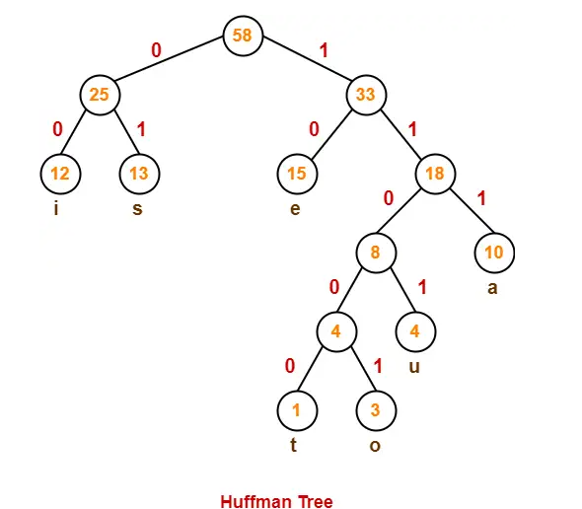

 Huffman Code for each character is-

* a = 111
* e = 10
* i = 00
* o = 11001
* u = 1101
* s = 01
* t = 11000